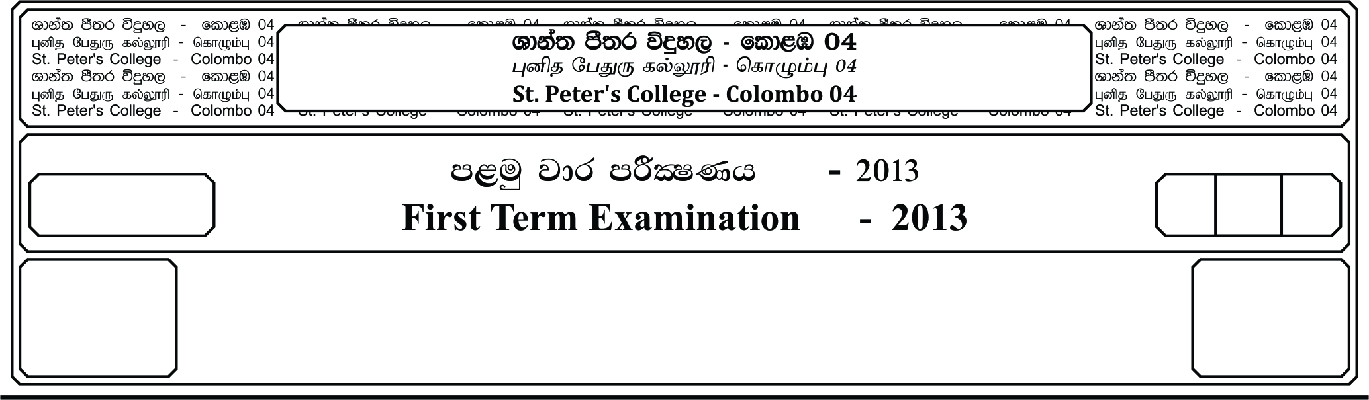

12 fY%aKsh

GRADE 12

E

meh 01

01 Hour

I

**fojk jdr mÍCIKh - 2019**

**Second Term Examination - 2019**

;¾l Ydia;%h yd úoHd;aul l%uh - »

**LOGIC & SCIENTIFIC METHOD – I**

24

● **Answer all questions.**

01. What a proposition generally mean is,

i. A mere sentence.

ii. An excalamation.

iii. A command.

iv. The meaning of a declarative sentence.

v. A sentence with only the subject and the predicate.

02. Select the symmetrical relation out of the following,

i. A is kind to B. ii. A’s brother is B.

iii' A is B’s father. iv. A is on the right side of B.

v. A is equal to B.

03. If it is given that “All flowers are fragrant” is true, then the truth values of E, I, O in order is,

i. True, True False ii. True, False, True

iii. False, True, False iv. False, True, True

v. True, True, True

04. Select from the following the one that is a valid mood of the forth figure,

i. CELARENT ii. CESARE iii. FERISON

iv. CAMENESv. CAMESTRES

05. Opposite concepts or characters cannot be true together. The answer which consists this idea

is,

i. The law of identity. ii. The law of contradictory.

iii. The law of excluded middle. iv. The law of sufficient reason.

v. The law of double negation.

06. “World is made of water.” Was stated by,

i. Ptolemy ii. Theles iii. Aneximenes

iv. Lucapusv. Pythagoras

07. The predicate term is always distributed in,

i. Universal Proposition. ii. Particular Proposition

iii. Affirmative Proposition iv. Negative Proposition

v. Singular Proposition

08. “All flowers are beautiful. Therefore some non-flowers are non-beautiful.” Is,

i. Obversion ii. Conversion iii. Contraposition

iv. Inversion v. Obverted Inversion

09. The father of Logic is,

i. Parmenids ii. Socrates iii. Hippocrates

iv. Aristotle v. Leibniz

10. The correct categorical structure of “Except for one swan all others are black” is,

i. All swans are white. ii. No swan is white.

iii. Some swans are black. iv. Some sawns are not black.

v. All swans are black.

11. Which of the following statement is correct for a valid syllogism.

i. Both premises must be affirmative.

ii. At least one premise must be negative.

iii. Both premises must be particular.

iv. At least one premise must be universal.

v. Both premises must be universal.

12. “All children are mischievous.

Some examination candidates are mischievous.

Therefore some examination candidates are children.”

Which of the following fallacy could be seen in the above syllogism?

i. Fallacy of four terms. ii. Fallacy of undistributed middle term.

iii. Fallacy of two propositions. iv. Fallacy of illicit major.

v. Fallacy of illicit minor.

13. A conditional proposition becomes true,

i. If the consequent is true.

ii. If the consequent is false and antecedent is true.

iii. When the antecedent is true.

iv. When the antecedent is true and consequent is false.

v. When we cannot decode the values of wither.

14. An example for the law of the excluded middle,

i. “A” will always be “A”. ii. Either it is good or not good.

iii. It is good and bad. iv. She cannot be a wife and a non-wife.

v. “A” will not always be “A”.

15. What is the answer which carries examples for a value science, a formal science and an

empirical science?

i. Aesthetics, Logic, Astrology ii. Aesthetics, Physics, Logic

iii. Ethics, Music, Psychology iv. Aesthetics, Logic, Economics

v. Music, Psychology, Devil Dancing

16. The correct symbdization of “Only men are wise”,

i. ii. iii.

iv. v.

17. Truth values of four variable is,

i. 2 Values ii. 4 Values iii. 8 Values

iv. 16 Values v. 32 Values

18. Deductive logic,

i. Moves from particularization to generalization.

ii. Concerns the structure of the argument.

iii. Concern the truth of the argument.

iv. Gives new knowledge.

v. Can be falsified.

19. Logic is a branch of………..,

i. History ii. Mathematics iii. Psychology

iv. Philosophy v. Astronomy

20. Dumb; Lame ; Deaf are,

i. Negative terms ii. Abstract terms iii. Contradictory term

iv. Privative term v. General terms

**(20×2=40 Marks)**